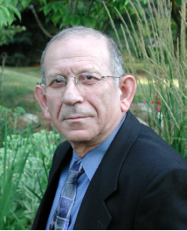 Yairi’s brief bio

Ehud Yairi, (B.A., Tel Aviv University, 1965; M.A., 1968, Ph.D., 1970, University of Iowa) has contributed extensively to the research literature on childhood stuttering for more than 30 years. His work has been focused on various analyses of speech disfluency, as well as the onset, development, and the genetics of stuttering. He was also active in the speech rehabilitation of head and neck cancer patients. He has been the PI of several large NIH grants concerning childhood stuttering, and is currently directing a multi-center grant for studying subtypes of stuttering. Professor Yairi has served on many NIH committees, as well as editorial boards of scientific journals. A native of Israel, he has given invited lectures and workshops in many countries around the globe. Among other recognitions, Yairi received teaching awards, the Distinguished Alumnus award from the renown University of Iowa Department of Speech Pathology and Audiology, the Outstanding Service Award, American Cancer Society, the King James McCristal Distinguished Scholar Award, University of Illinois, and was the first to have received the Researcher Award of Distinction from the International Fluency Association. A Fellow of the American Speech-Language-Hearing Association, Yairi is a recipient of its highest award -- the Honors of the Association.

